Description:

State Machine for enabling write controller, determine when to enable the WC.

RC enable is through WC_finish signal

Generic table

|  |  |  |
| --- | --- | --- |
| Name | Width | Description |
| reset_polarity_g | 1 | '1' reset active high, '0' active low |
| enable_polarity_g | 1 | '1' the entity is active high, '0' entity is active low |

Signals table

|  |  |  |  |
| --- | --- | --- | --- |
| Name | Direction | Width | Description |
| clk | In | 1 | System clock |
| Reset | In | 1 | System reset |
| Enable | In | 1 | Enabling the entity. if (enable = enable_polarity_g) -> start working, else-> do nothing. Come from registers |
| wc_finish | in | 1 | '1' ->WC has finish working and saving all the relevant data (RC will start work), '0' ->WC is still working |
| rc_finish | in | 1 | '1' -> read controller finish working, '0' -> system still working |
| enable_out | Out | 1 | Enable send to the write controller to start saving the data and searching trigger rise |

Enable state machine

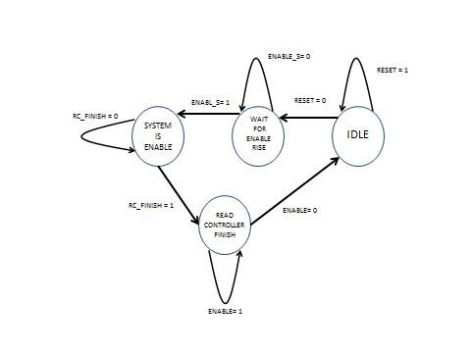

Output table

